**Lesson 6 Demo 9**

**Adding Entries to pod/etc/hosts with HostAliases**



Steps to be followed:

1. Adding entries to resources with host aliases

**Step 1: Adding entries to resources with host aliases**



1. Get Default hosts for the pod **webserver** that we created earlier

***kubectl exec webserver -- cat /etc/hosts***

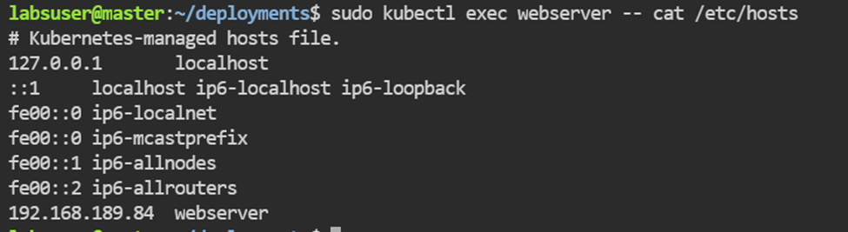

1. Creating a configuration with additional entries

***apiVersion: v1***

***kind: Pod***

***metadata:***

***name: hostaliases-pod***

***spec:***

***restartPolicy: Never***

***hostAliases:***

***- ip: "127.0.0.1"***

***hostnames:***

***- "foo.local"***

***- "bar.local"***

***- ip: "10.1.2.3"***

***hostnames:***

***- "foo.remote"***

***- "bar.remote"***

***containers:***

***- name: cat-hosts***

***image: busybox***

***command:***

***- cat***

***args:***

***- "/etc/hosts"***

1. Create the resource

***kubectl apply -f hostaliases.yaml***



1. Examine pod details

***kubectl get pod -o wide***

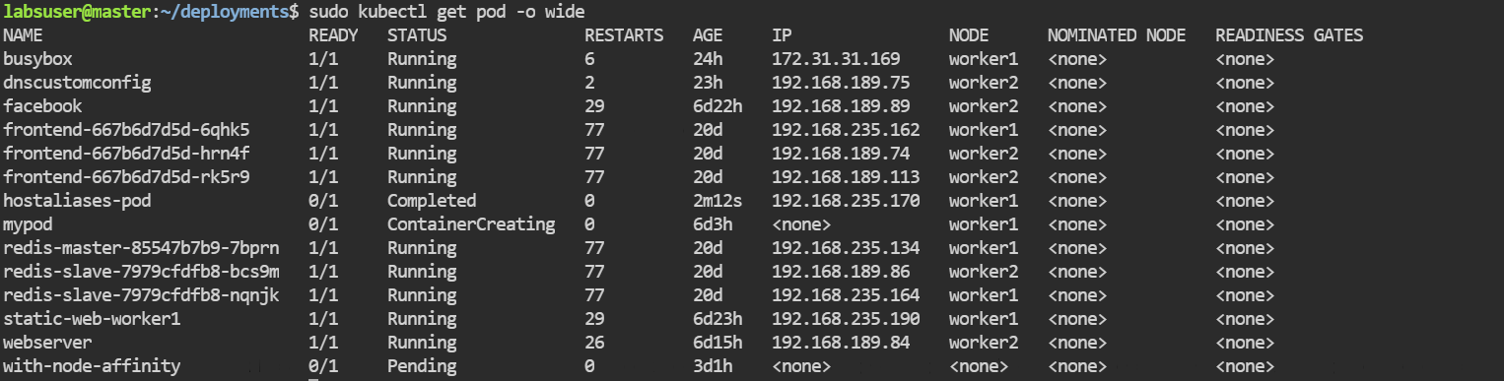

1. Observe logs

***kubectl logs hostaliases-pod***

